Insert Paper Title (14 pt bold)

Raimondo Manca¹, Christos H. Skiadas², and Jacques Janssen³

¹ Department of Methods and Models for Economics, Territory and Finance via del Castro Laurenziano,9, Universita “La Sapienza", Roma, Italy
(E-mail: raimondo.manca@uniroma1.it)
² Technical University of Crete, University Campus, 73100 Chania, Crete, Greece
(E-mail: skiadas@cmsim.net)
³ EURIA (Brest) and JACAN (Tubize) Universit_e de Bretagne Occidentale 6 avenue le Gorgeu, CS 93837, 29238 BREST Cedex 3, France
(E-mail: cesiaf@belgacom.net)

Abstract. A refereed selection of proceedings papers will be published in a permanent conference website in Electronic form. In these guidelines we describe the format instructions and the submission procedure both to be followed seriously. The text of these guidelines is written in the prescribed format and can be used as a specimen.
Please note that if you don't like to submit a paper you only have to submit an Abstract by using the Electronic Submission Form from the Conference web site.
Keywords: Conference, Demographics, SMTDA, ASMDA, CMSIM Style file.

Paper length from 8-14 pages. Optimum 12 pages (Times New Roman: text 10pt, titles 12pt bold, Affiliations, Abstract and References 9pt)
Please submit both Word and PDF files.

1 Introduction

Add introductory text here…..

2 Input the Title of the second section

Add text…

3 Input the Title of the third section

Add text……..

………………………………….

4 Input the Title of the fourth section

Add text……..

One Figure appear as:

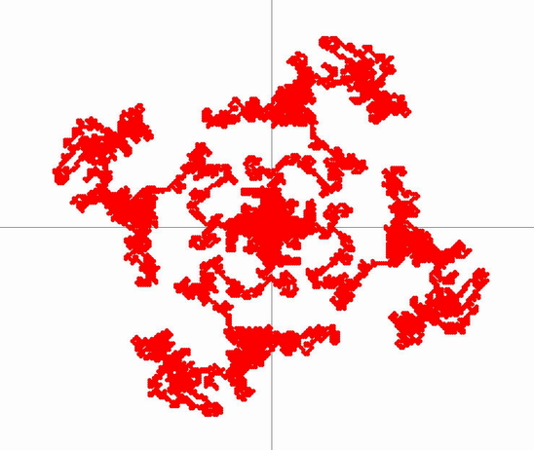
Fig. 1. Caption Text 1

………………………………….

Two Figures can appear as follows:

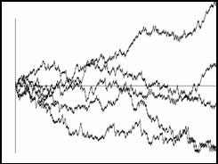 | 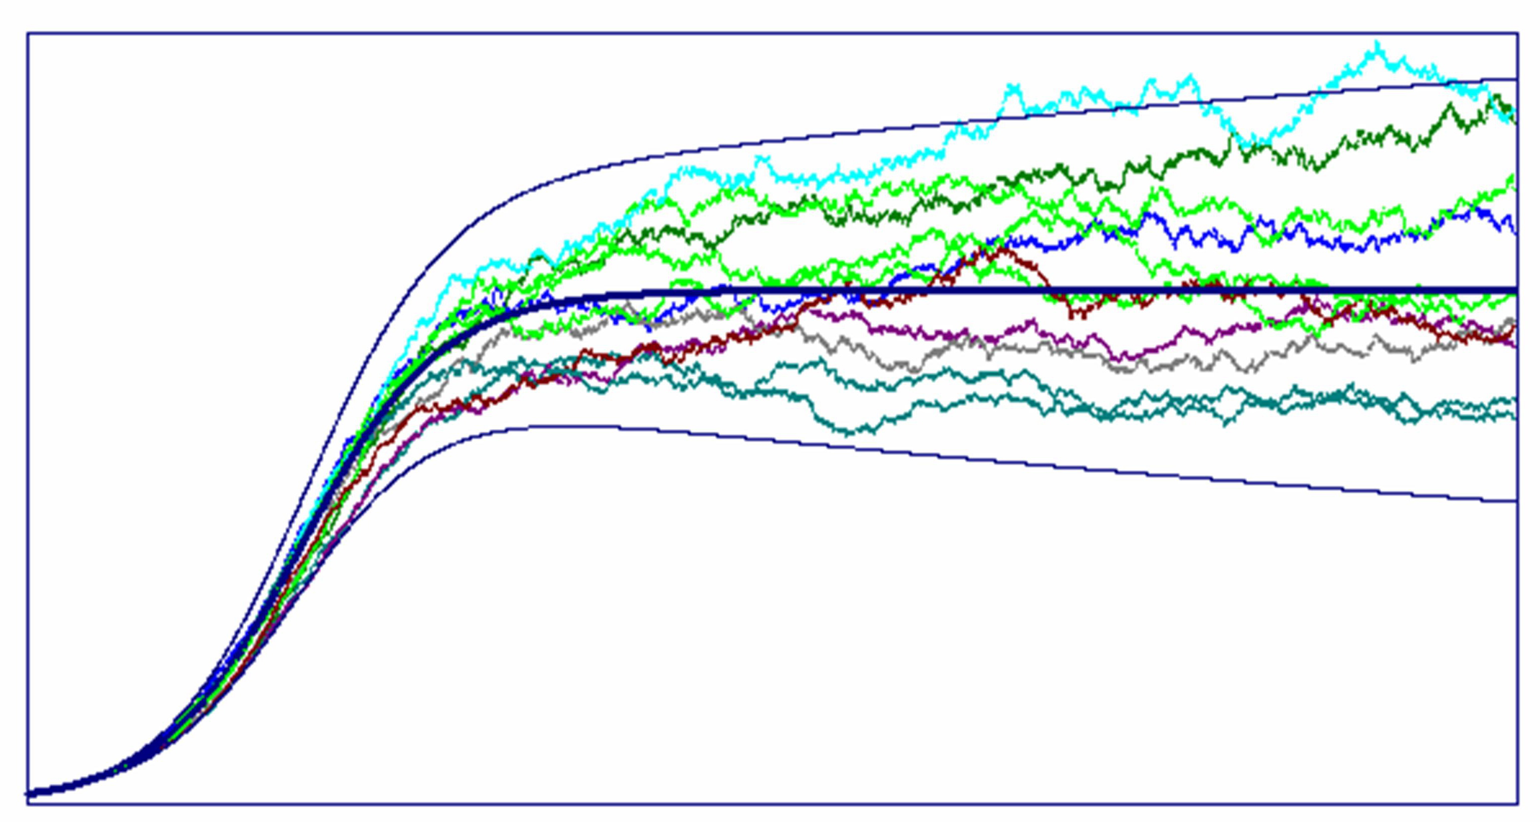
Fig. 2. Caption Text 2 | Fig. 3. Caption Text 3

Conclusions

Add text………………….

References

1. G. DAmico, J. Janssen and R. Manca. Homogeneous semi-Markov reliability models for credit risk management. Decisions in Economics and Finance, 28, 2, 79{93, 2005.
2. J. Janssen and R. Manca. Semi-Markov risk models for finance, insurance and reliability, Springer, New York, 2007.
3. J. Janssen and C.H. Skiadas. Dynamic modelling of Life-Table data, Applied Stochastic Models and Data Analysis, 11, 1, 35{49, 1995.
4. G. Saporta, Probabilités Analyse des Données et Statistique, Editions Technip, Paris, 1990.

